**FUNCTIONAL AND TECHNICAL COMBINED DOCUMENTATION**

**Page (28): Search Specific Stocks (Front End Url:** http://localhost:8100/page28/Page28)

**Functional Picture:**

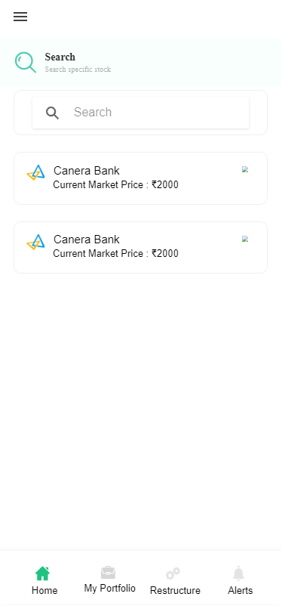

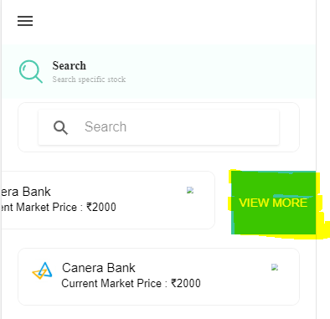

**In this Page, the user can search for a particular stock from the NSE stock universe.**

**Technical Explanation (Front End and Back End):**

**In Page28.tsx, we are calling following 1 API:**

1. SearchAPI: see backend python file. In this we are doing GET requests.

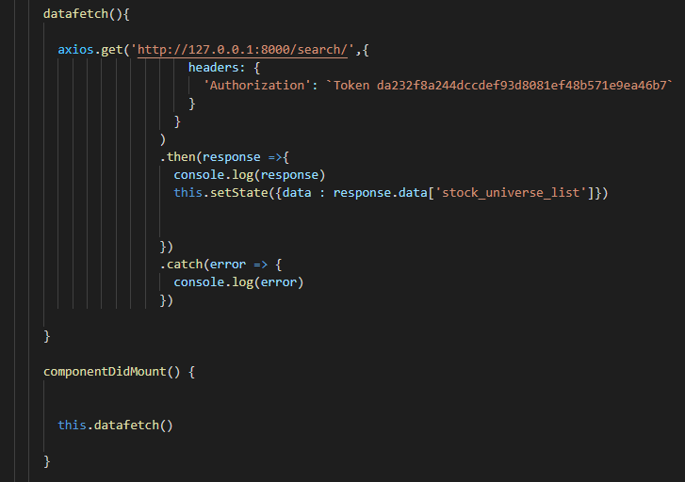

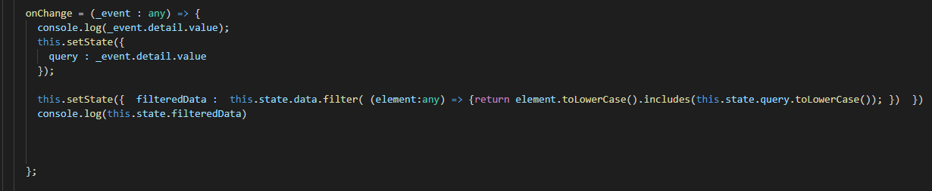

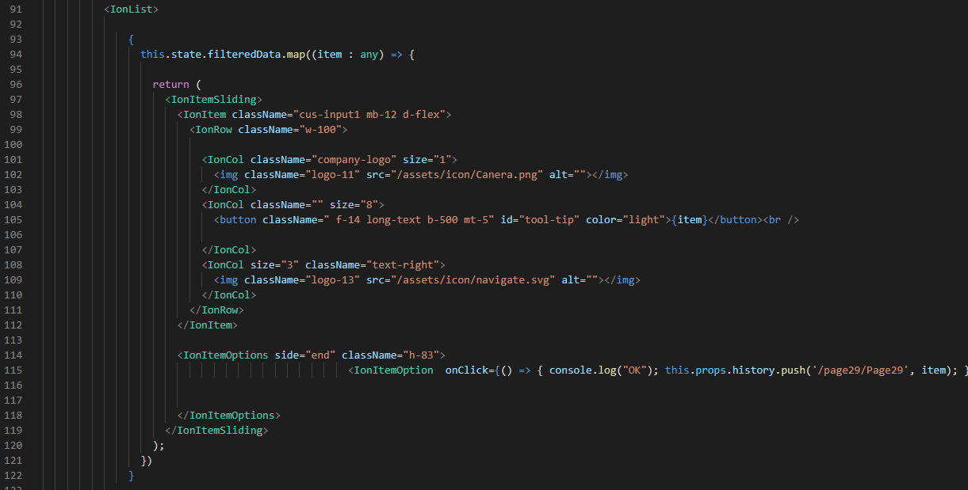

**As you can see, we are calling the** SearchAPI

**using this url:** [**http://127.0.0.1:8000/search/**](http://127.0.0.1:8000/search/)**. In this we can search for stocks from the NSE stock universe.**

**Kindly see the given below backend Code for this GET request.**

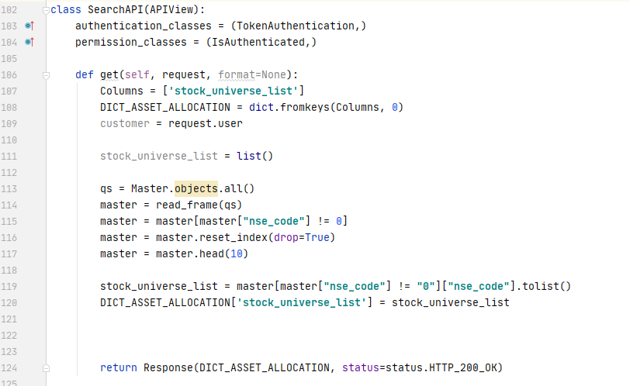

**The Above API is taking the data from Master table Database throwing the data on the front end through Response by filtering then with stockname in the search bar.**

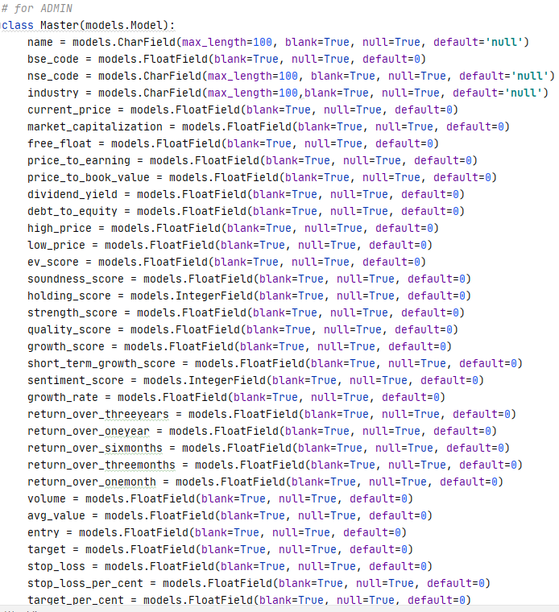

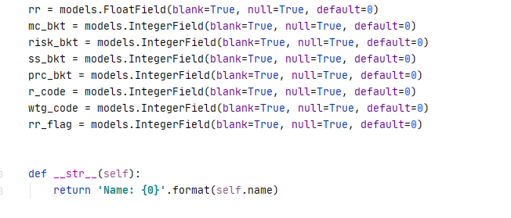

**DONE!!!**